- Sign up for a free Jira account, create a new project named 'Food Delivery App QA', and add a sample bug titled 'Order status not updating after payment'.
Ans=>

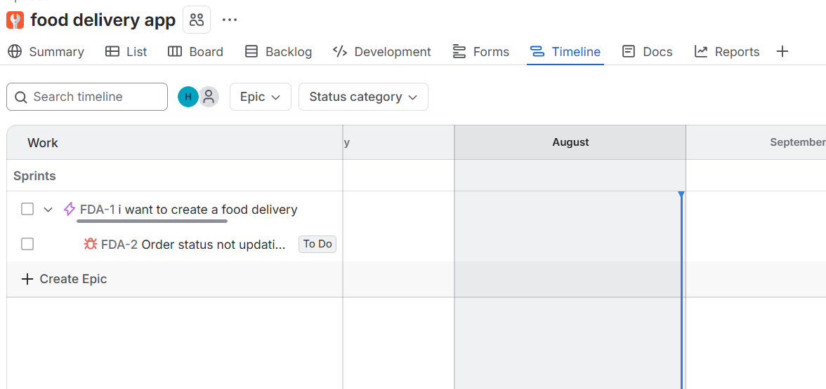

- Fill out a defect report in Jira for a bug you found in any app you use daily (like Zomato, Flipkart, or Paytm), using all main fields: Summary, Description, Steps to Reproduce, Expected Result, Actual Result, Severity, and Priority.<br><br><em><strong>Hint:</strong> Use a real or imagined bug, but make the details specific and realistic.</em>
Ans=>
Defect Report
Summary: Cart quantity resets to 1 after returning from the product details page
Description:
When a user increases the quantity of an item in the shopping cart and navigates to the product details page, returning to the cart resets the item quantity to 1. The cart should retain the quantity selected by the user throughout the session.
Expected Result:
The cart should retain the previously selected quantity of 3, and the subtotal should be recalculated based on the quantity of 3.
Actual Result:
The product quantity is reset to 1, and the cart subtotal is recalculated for a single item.
Severity: Medium — the issue does not prevent checkout, but it can cause users to order an incorrect quantity.
Priority: High — incorrect cart quantities can directly affect customer orders and should be fixed promptly.

- Given these three bugs found in a movie ticket booking app: (1) Payment fails for UPI, (2) Movie poster image is blurry, (3) App crashes if you book more than 10 tickets at once — classify each bug as High/Medium/Low Severity and High/Medium/Low Priority, and justify your choices.
Ans=>
Bug | Severity | Priority | Justification
1. Payment fails for UPI | High | High | Payment failure blocks users from completing bookings through a major payment method and can directly cause lost transactions/revenue.
2. Movie poster image is blurry | Low | Low | This is primarily a cosmetic/UI issue. It does not prevent users from searching for movies, selecting shows, or completing bookings.
3. App crashes when booking more than 10 tickets | High | Medium | A crash serious

- Draw the complete bug life cycle for a typical defect in Jira, labeling each stage (for example: New, Assigned, In Progress, Fixed, Retest, Closed, Reopened) and describing what happens at each step.<br><br><em><strong>Hint:</strong> You can use a simple flowchart tool or draw and scan a diagram, but your answer must include both the diagram and brief descriptions.</em>
Ans=>
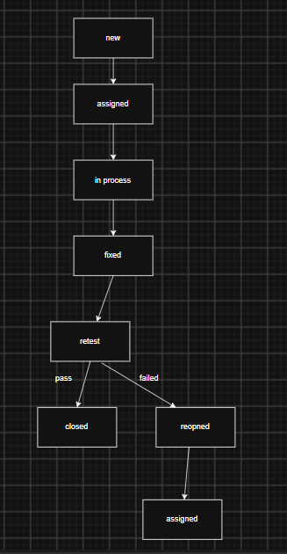

- Download a sample defect template from the internet (or use a template provided in class), and fill it out for a bug you noticed in any social media app (like Instagram or WhatsApp), making sure to include Severity and Priority fields.
Ans=>
